Roasted Hazelnut & Pistachio Bark
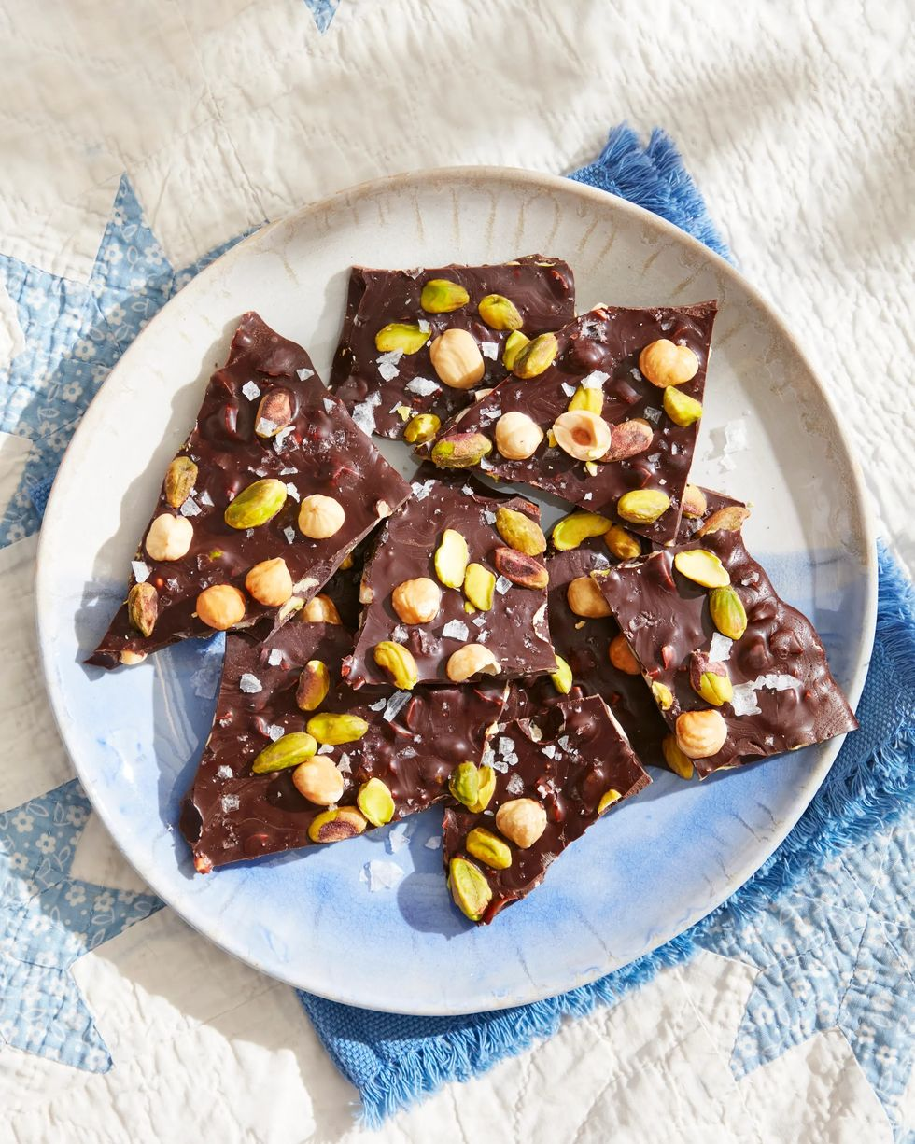
DESCRIPTION:
This decadent dessert is made from just three ingredients: dark chocolate, flaky salt, and toasted nuts. The darker the chocolate, the less sugar is in it!
INGREDIRNTS:
1/2 c. roasted pistachios, divided
1/2 c. roasted hazelnuts, divided
3 (3.5-ounce) bars 72% dark chocolate, chopped
1/3 tsp. flaky sea salt
DIRECTION:
SAVE RECIPE
Step 1
Line a rimmed baking sheet with parchment paper. Chop 1/4 cup each pistachios and hazelnuts. Place chocolate in a heatproof bowl; set over, not in, a pot of simmering water. Cook, stirring occasionally, until chocolate is melted. Stir in chopped nuts.
Step 2
Pour chocolate mixture on prepared baking sheet and spread to a 10-inch circle. Sprinkle with remaining 1/4 cup each whole pistachios and hazelnuts. Sprinkle with flaky salt. Refrigerate, until chocolate is hard, about 1 hour. Break into pieces before serving.

